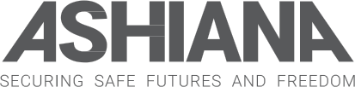
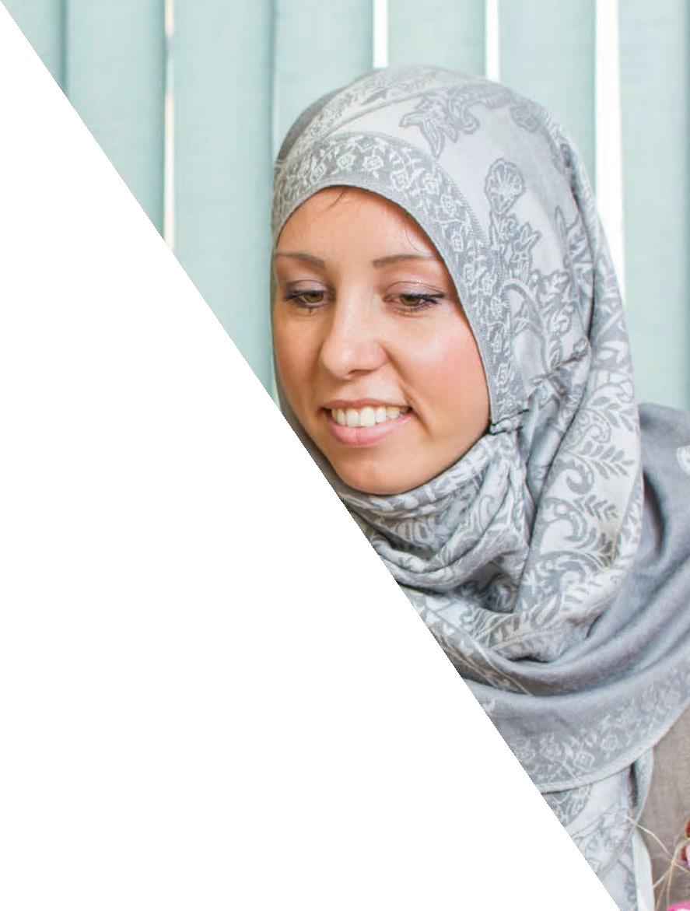

CAREER OPPORTUNITIES
at Ashiana

Contents
- Welcome by the
Chair and CEO
- About Ashiana
- The vision, mission, values

- Working for Ashiana
- What we offer
- How to Apply

Welcome to Ashiana

Thank you for your interest in a possible career with Ashiana.

Ashiana is very proud of the positive development and impact achieved over our 35 plus years for women and children whose lives have been affected by violence and abuse.

We provide a unique and outstanding service however; we know much more needs to be done. Thousands of people are living in abusive situations every day, hidden away and in silence. We aim to shine a light on these hidden and harmful practices and support those that have been affected by them.

Our five-year strategic plan has challenged us to focus and develop our service to maximise our impact.We also fulfil a huge agenda to really improve services and support for BAMER women and children affected by violence e and abuse.
To achieve this, we need a team of excellent staff who are committed to our values and are the best in their field.

Daljit Kaur, Chair

We are going through an exciting period of change and are looking for experienced individuals who want to make a difference and are willing to dedicate time and energy to the cause. We are seeking individuals who share our passion for the charity to grow and be successful.
We are aiming to recruit individuals from diverse backgrounds, skills and experiences; to enable us to be the best we can be.

In return, you can expect a competitive salary, generous leave allowance, staff pension and flexible working. We are committed to equality and diversity and strive to ensure the best possible environment and working experience for our staff and volunteers.

Information on these exciting opportunities are attached, along with our vision, mission and values. We hope you will want to join us and help us transform life chances for vulnerable people we look forward to receiving your application. Thank you for your support.

Rukhsana Haleem
CEO

About Ashiana

Established in Sheffield as a small refuge for women from South Asian Communities over 35 years ago, Ashiana has now become one of the leading specialist service s supporting women from all Black, Asian, Minority Ethnic and Refugee (BAMER) communities, supporting and empowering them to escape violence and abuse.

The aim of our work is to increase life opportunities to enable those that are vulnerable to move away from the risk of violence and into safe, stable and happier futures and we achieve this in a variety of ways including support services, accommodation, individual grants and donations, volunteering, education, training and employment, support services, awareness raising and campaigning.

Our growing staff team of over 45 have a vast collection of knowledge and experience and specialise in those areas of abuse which are most prevalent within BAMER communities such as domestic and sexual abuse, forced marriage, female genital mutilation, human trafficking, gang violence and ‘honour’-based violence. This team is supported by a dedicated board of trustees with a wealth of experience and commitment to making a change for some of the most vulnerable people in the world.

WE EMPOWER
Survivors are at the heart of everything we do. From our refuges to our groups and classes, we transform the lives of those affected by violence and abuse.

WE SUPPORT
No one should suffer alone. Ashiana provides support hundreds of people a year, supporting them to access their rights and entitlements and move on into safer, happier futures.

WE CAMPAIGN
We break the silence surrounding violence and abuse issues by speaking out to change attitudes and policies. Driven by the experiences of survivors , we campaign to ensure e those suffering or at risk of, get fast, effective support.

WE HELP PROFESSIONALS
Many professionals tell us they don’t have the knowledge and training to spot problems or help if needed, particularly in relation to cultural differences. We help schools, further education providers and multi sector professionals make a real difference.

WHERE WE WORK:
Ashiana head office is based close to Sheffield City
Centre, although as an organisation, we are active all over the UK, with hubs in many northern cities.
WHEN WE WORK:
Standard Office hours are 9.00am – 5.00pm.
Some of our employees work non-standard hours - we have a number of part-time staff, and some of our team work on a sessional basis. Ashiana recognises the importance of helping its employees balance their work and home life and so we have a Flexitime system in place as well as 30 days annual leave per annum (based on full time
hours).
EQUALITIES AND INCLUSION:

Ashiana is fully committed to eliminating discrimination and promoting equality and diversity in our workforce and employment practices, in the work we undertake, and in the provision of all our services.
We therefore expect all of Ashiana staff to be willing and able to make a positive contribution to the promotion and implementation of Ashiana Equality and Diversity policy.

SAFEGUARDING:
Ashiana is committed to safeguarding and promoting the welfare of vulnerable adults, children and young people and we therefore expect all staff and volunteers to do the same. We ask all staff to undertake safeguarding training when they join us and then regularly as required throughout the duration
of employment.

OUR VISION
A world where everyone can live free from fear and harm

OUR MISSION
To support and empower those from Black, Asian, Minority Ethnic and Refugee (BAMER) communities whose lives have been affected by violence and abuse to take control of their
lives and move forward into healthy, stable and safer futures.

OUR VALUES
Respect Trust & Honesty Empower

About this exciting opportunity

Are you an inspiring, driven and compassionate individual, passionate about making a difference? If so, Ashiana are recruiting for some exciting new roles to support and develop our services for women whose lives have been affected by violence and abuse.
Ashiana is looking for committed individuals to work with and support the Senior Management Team to develop and build upon our existing work.

THE ROLES INCLUDE:

Area Lead – East Midlands and South Yorkshire
Modern Slavery and Human Trafficking Project
Refuge Support Worker – South Yorkshire and West Yorkshire
Modern Slavery and Human Trafficking Project
Outreach Worker – South Yorkshire, West Yorkshire, East Midlands, and Humberside
Modern Slavery and Human Trafficking Project
Project Officer – Advocacy, South Yorkshire and west Yorkshire
Domestic Abuse and Human Trafficking

Some roles will require regional and national travel which will be specified on Job Descriptions

For individual Job Descriptions and Person Specifications, please visit our website
http ://www.a shianasheffield.org/get-involved/#Careers or contact Ayesha Imani Recruitment Support Pranisha Oli p.oli@ashianasheffield.org

ABOU T YOU
You will have experience with a proven track record relevant to your chosen role. You will be committed to the values of the organisation in supporting vulnerable women and children, who can drive our aim to enhance services.
Excellent IT skills and experience of working with management information systems/ processes would be an advantage.
The ideal candidates will identify as a Black, Asian, Minority Ethnic and Refugee (BAMER) woman and have a good understanding of challenges facing BAMER women and children who have faced violence and abuse, and how to support them.
This is a fantastic opportunity for anyone who would like to use their skills across a range of sectors to support a leading local charity and improve the quality of life of some of the UK’s most vulnerable women and children.
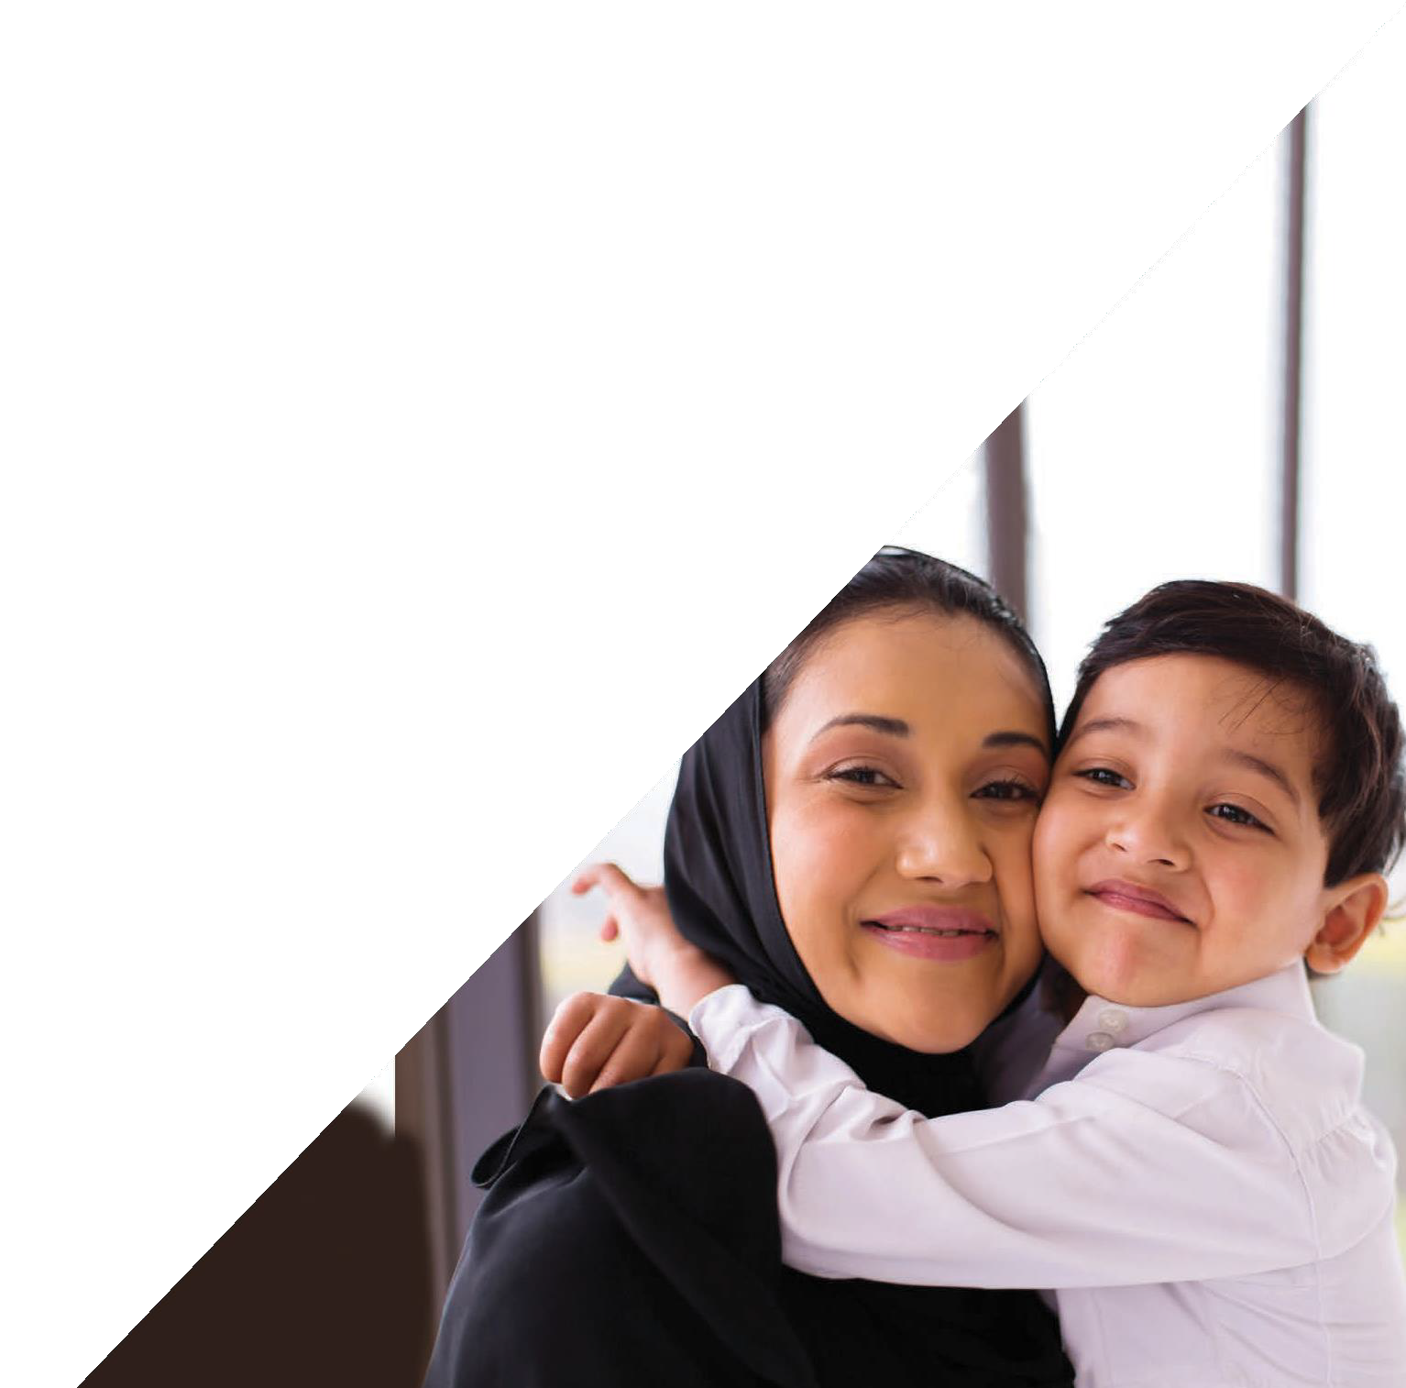
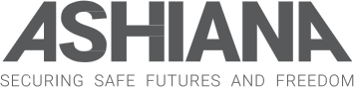

Nina Forrest – N.Forrest@ashianasheffield.org - West Yorkshire Refuge Lead
Michelle Montanino M.Montanino@ashianasheffield.org – North East Area Lead

Or the Chair Daljit Kaur on MsDkaur@aol.com

.org>

Ashiana is committed to ensuring our workforce is
reflective of our service user population and is therefore committed to increasing representation of staff of Black, Asian and Minority Ethnic backgrounds across all roles and at all levels.
Successful applicants will be required to have a satisfactory enhanc e d disclosure through the DBS scheme.
Ashiana is a company limited by guarantee
Registered No 5853854: Charity No. 1120401.

How to Apply

Please visit http://www.ashiana she ffield.org/get-involved/#Careers for further information on each role and an application pack.

For an informal chat;

For these great opportunities on offer

You can also make contact with the Area Lead and the Domestic Abuse and Community Engagement Lead as below:

Yasmin Aslam, y.aslam@ashianasheffield.org, - Domestic Abuse and Community Engagement Lead

Nina Forrest N.Forrest@ashianasheffield.org - West Yorkshire Refuge Lead

Raimonda Kirtiklyte R.Kirtiklyte@ashianasheffield.org - South Yorkshire Outreach

Natalie O’Neale - n.o’neale@ashiansheffield.org Area Lead Refuge West Yorkshire

Isha Kaur I.Kaur@ashianasheffield.org - West Yorkshire Area Lead Outreach

Michelle Montanino M.Montanino@ashianasheffield.org - Area Lead North East

CEO

R.haleem@ashianasheffield.org

Contract Lead

Brigitta Laszlo, B.Laszlo@ashianasheffield.org

The posts are restricted to female applicants pursuant to Section 9s of the Equality Act 2010.

